**Use tables in adobe forms**

1. Go to Tcode SFP .Create an interface and then create a form(For details ,please refer the previous demo)

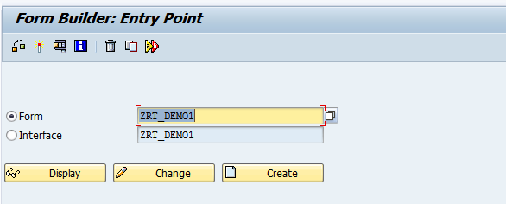

1. In the interface add internal table it_Sflight of table type ztt_Sflight_rt

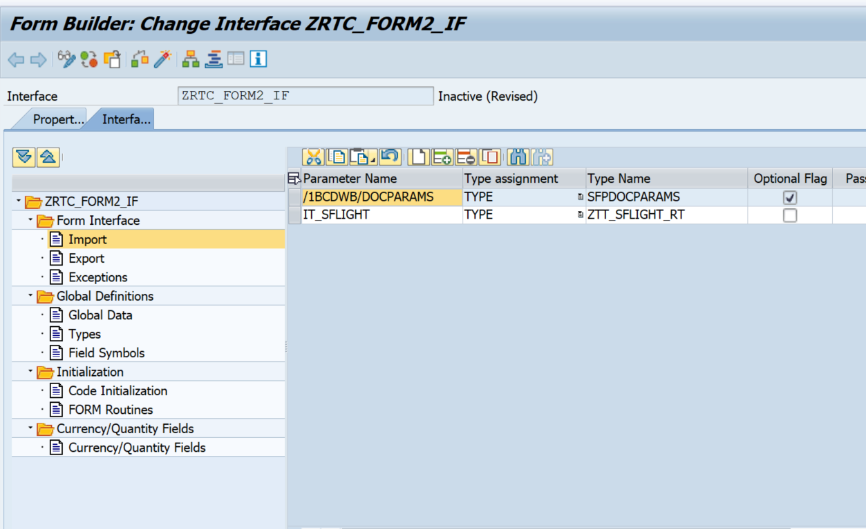

1. In the Global data, declare the internal table IT_SFLIGHT.(Note:Here ZRT_SFLIGHT is table type created in se11)

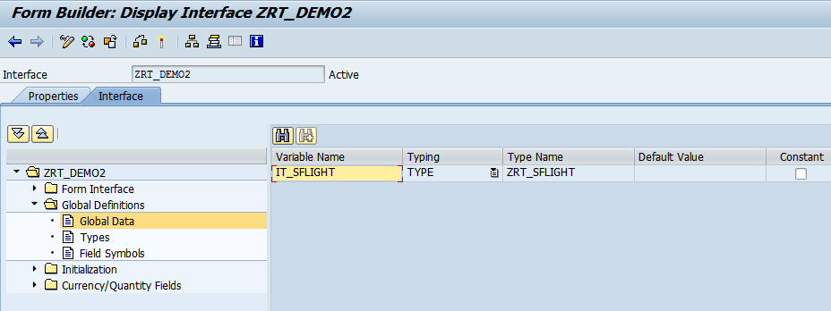 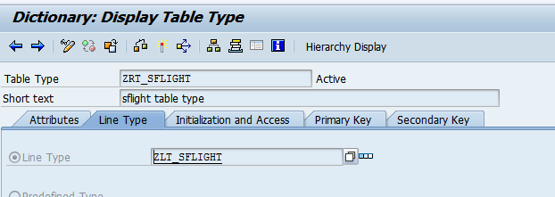

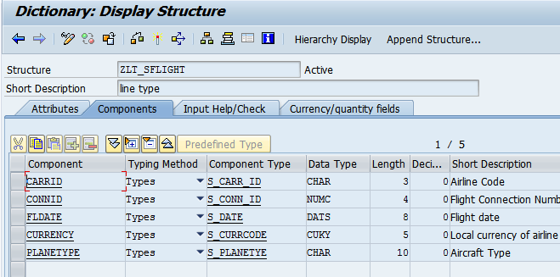

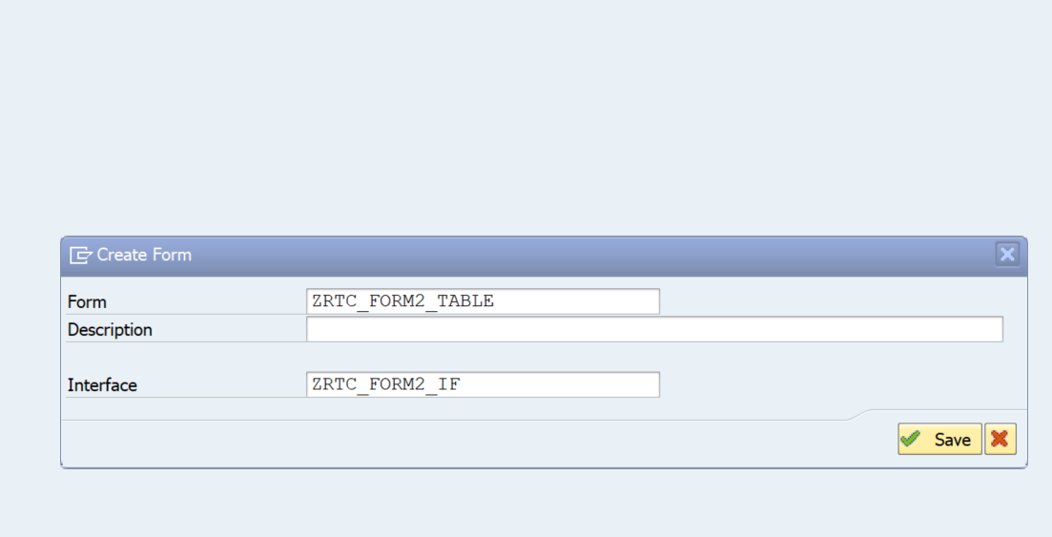

1. Open the Adobe form. Drag and drop it_sflight Interface section to Context.Save. Then click on Layout.

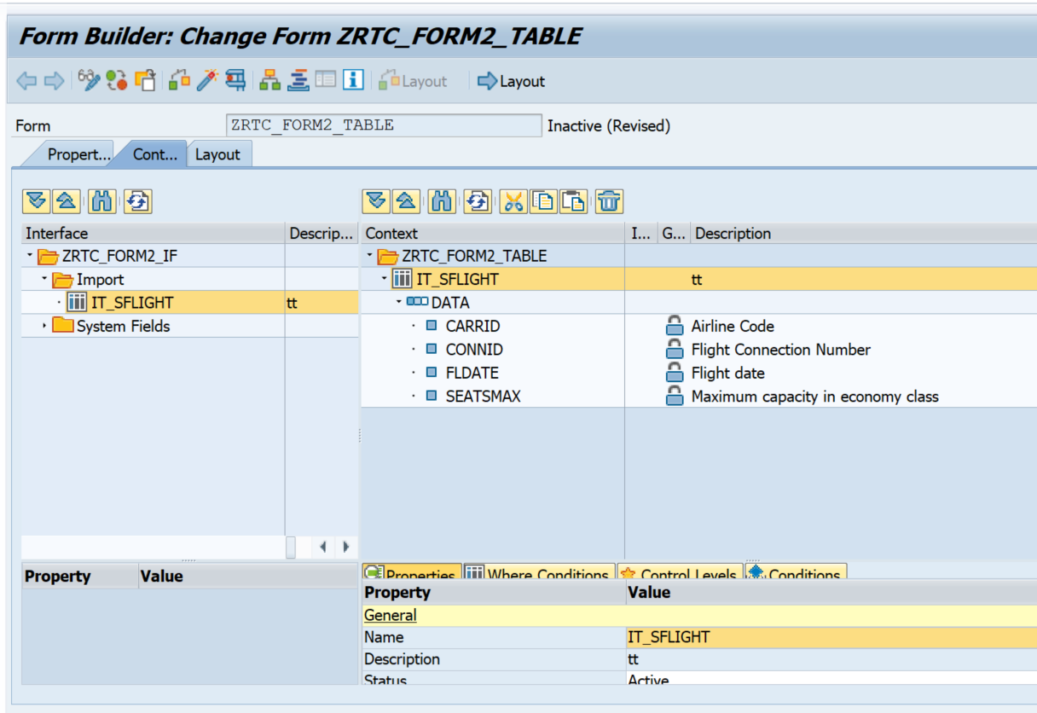

1. Go to the dataView tab. 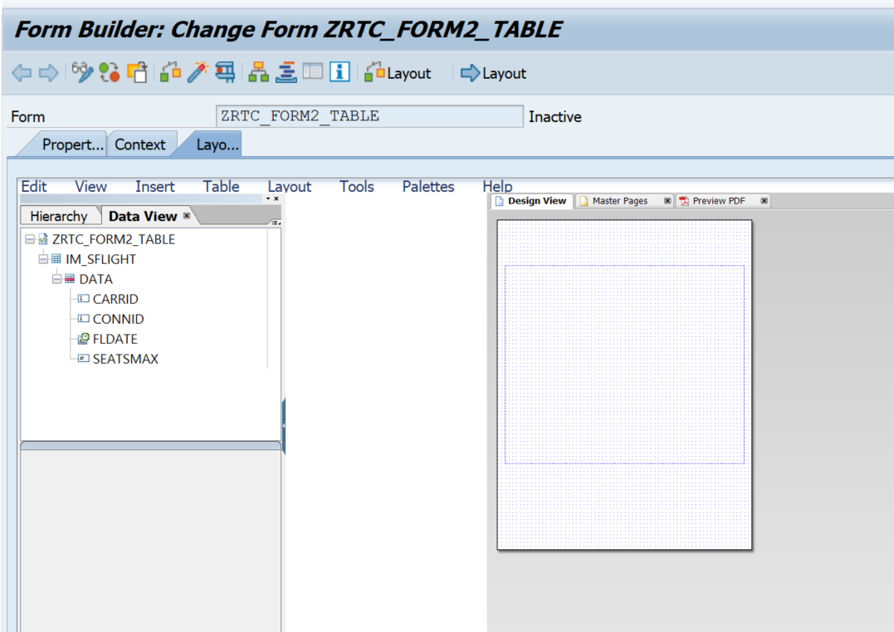
2. Drag and drop the internal table IM_SFLIGHT to the DesignView.Place the table inside the subform(Blue dotted box).

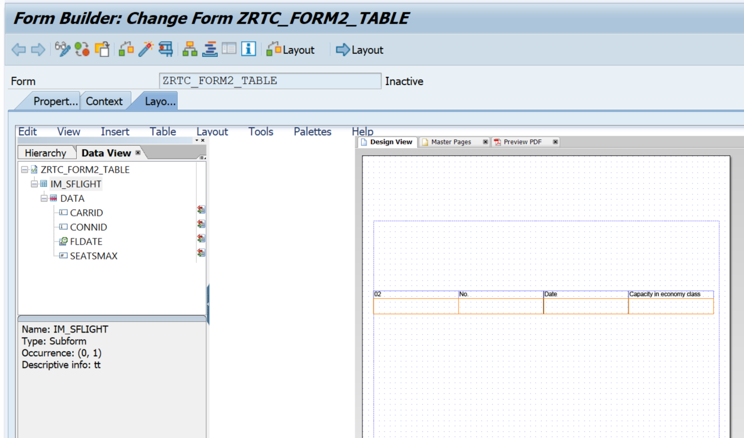

1. Go to hieracry tab .
2. Rename the suborm as TableSubform

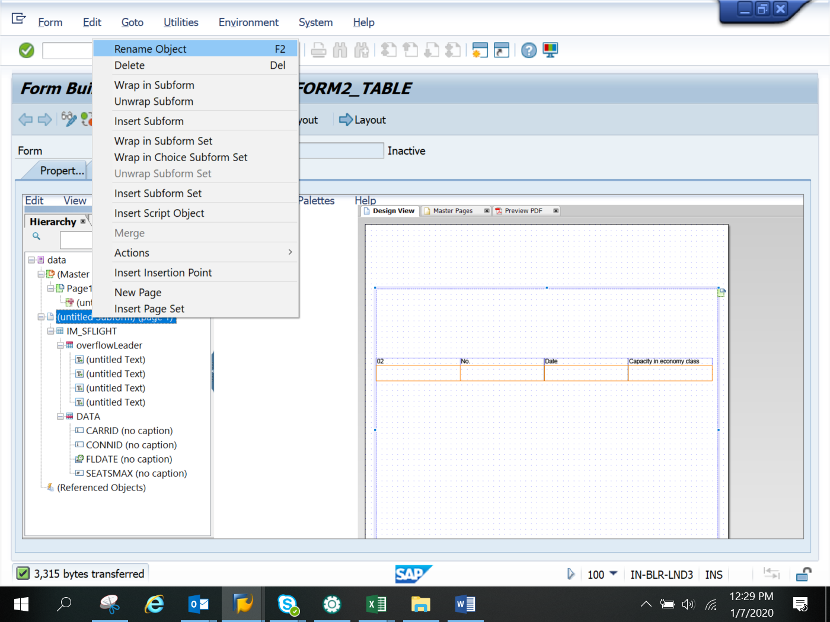

1. Edit the properties of the TableSubform.Change from positioned to Flowed.
2. 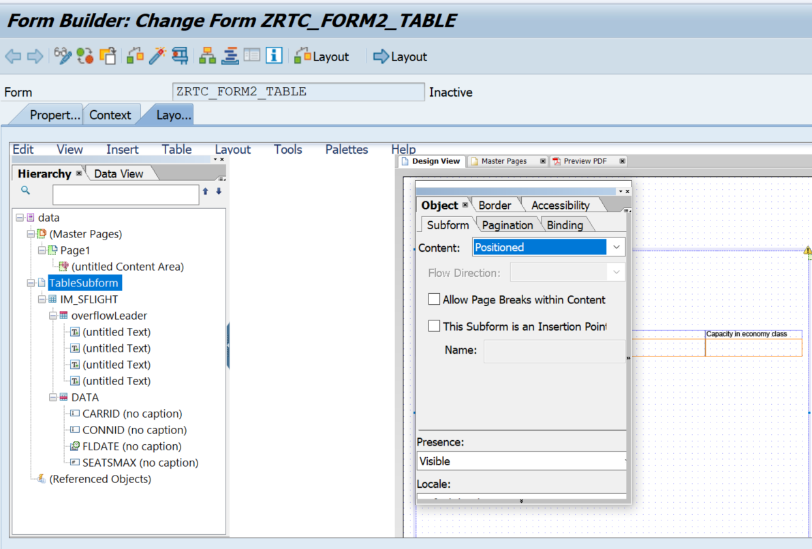
3. 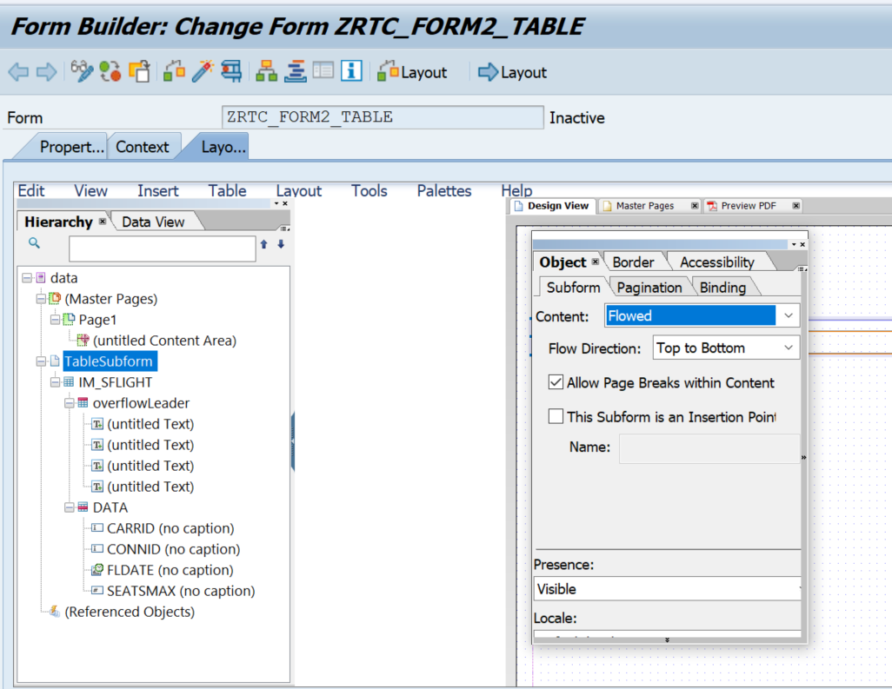From the data view, drag and drop the internal table IT_SFLIGHT into the subform.Make sure the table fits inside the subform dfgsd

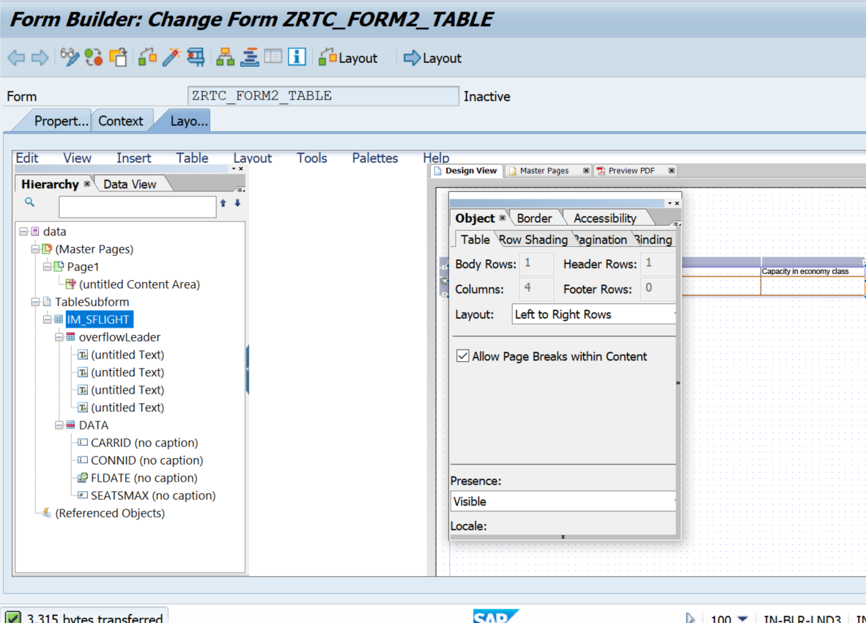

1. Double click on ITS_FLIGHT .The object window of IT_SFLIGHT opens up. **Check on the Allow Pagebreaks with content checkbox**

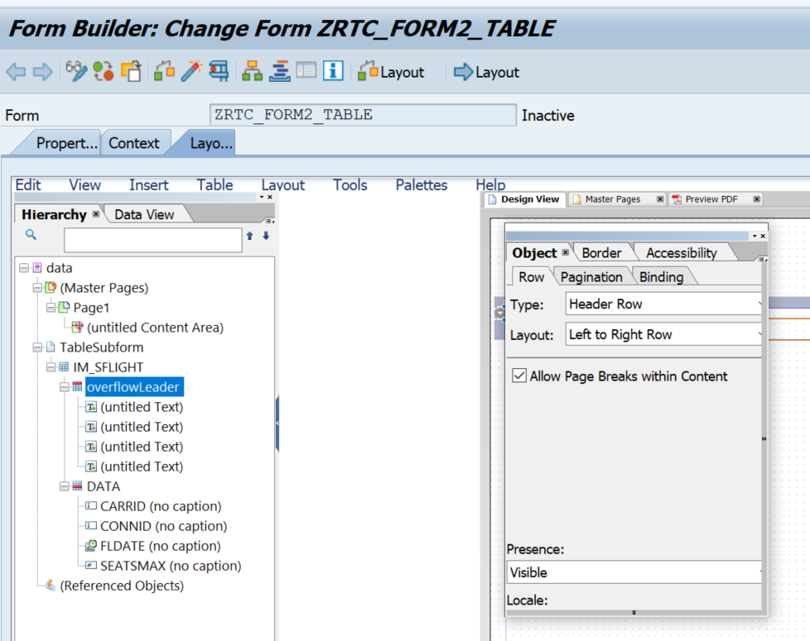

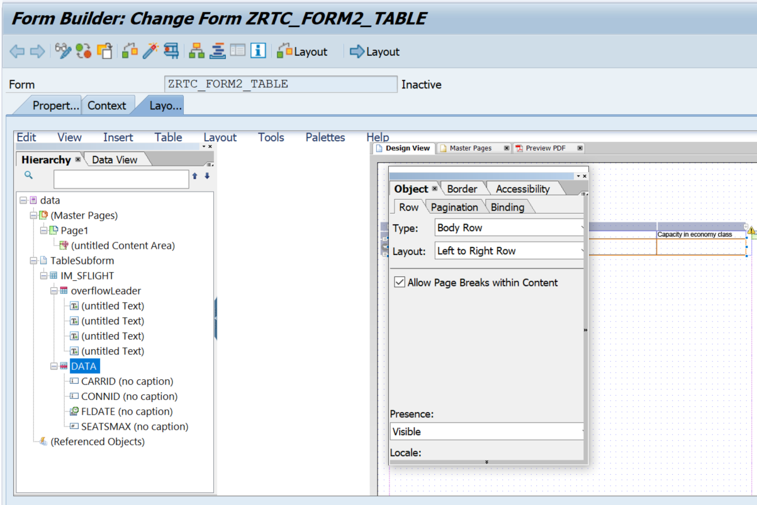

1. In the Hierarchy tab, double click on the Subform1.In the Object window, give the details as shown below.

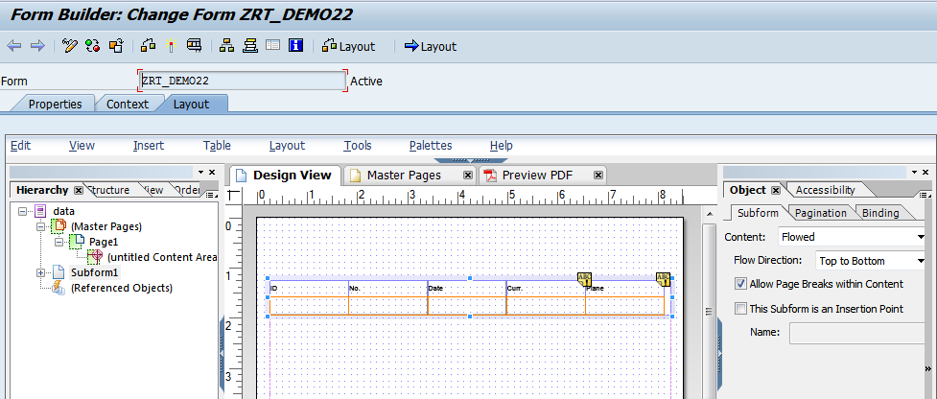

1. Click on context. Save and activate the form
2. Execute the form .Execute the function module

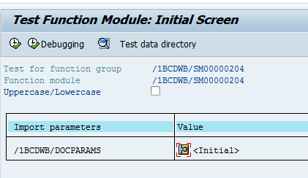

1. Click on Print preview

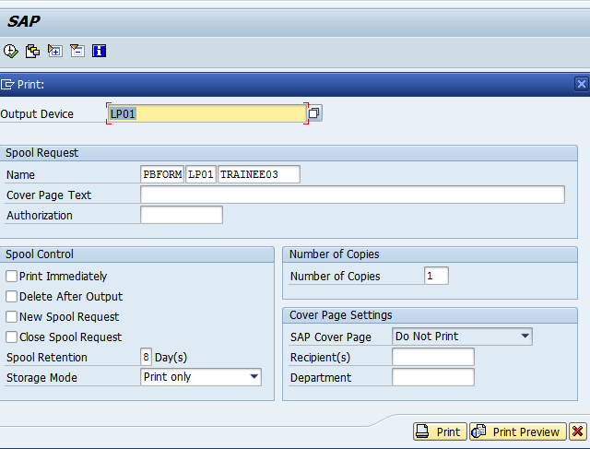

1. Expected output is as follows.

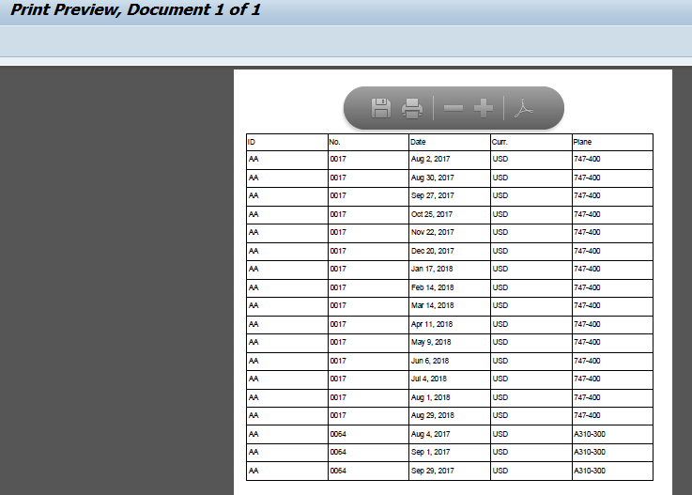

Data flows to the next page succesfuly.

